**LUCKNOW PUBLIC SCHOOL**

**(C. P. SINGH FOUNDATION)**



**Project Report**

Informatics Practices (065)

(Session: 2022-23)

Student Name : Ashutosh Prajapati

Class : XI

Section : A

Roll No. : 18

# CERTIFICATE

This is to certify that this work is submitted by **Ashutosh Prajapati** to the Informatics Practices

Department of Lucknow Public School Sector-F

Jankipuram Lucknow and was carried out under the supervision and guidance of Head of Informatics Practices Mr. Abhay Pratap Singh during the Session 2022-2023.

Date Teacher In charge

Principal Examiner

# ACKNOWLEDGEMENT

I take this opportunity with great pleasure and respect to express my first and foremost thanks to the principal, “Mrs. Sushmita Sarkar” for her encouragement and for the facilities that she provided for this project work. I extend my hearty thanks to “Mr. Abhay Pratap Singh”, Informatics Practices Teacher who guided me throughout the successful completion of this project. I take this opportunity to express my deep sense of gratitude for his guidance, constant encouragement, immense motivation, which has sustained my efforts at all the stages of this project.

I can’t forget to offer my sincere thanks to the parents and to also my classmates who helped me to carry out this project work successfully and for their valuable advice and support, which I received from time to time.

Ashutosh Prajapati

XI-A

# CONTENT

* + INTRODUCTION
  + SOFTWARE & HARDWARE REQUIREMENT
  + SOURCE CODE IN PYTHON
  + OUTPUT SCREEN

# INTRODUCTION

MySQL Connector/Python enables Python programs to access MySQL databases, using an API that is compliant with the Python Database API Specification v2.0 (PEP 249). It is written in pure Python and does not have any dependencies except for the Python Standard Library.

In the project, using MYSQL connector we have performed following tasks :

* Creating a database
* Creating table
* Inserting data into table
* Modifying and deleting data from table

## SOFTWARE AND HARDWARE REQUIREMENT

Software Specification: -

Operating system: Windows 10/8/7 Platform: Python IDLE 3.8, MySQL

Languages: Python

Hardware specification: -

Processor: Dual core or above

Hard Disk: 40 GB RAM: 1024MB

Note:

Please install the following libraries before running the program:

* Python IDLE
* MySQL

# SOURCE CODE

import mysql.connector

conn = mysql.connector.connect(host="localhost",user="root",password="1234")

print(conn)

cr = conn.cursor()

cr.execute("CREATE DATABASE DBXIA")

print("-+-+-+-+-+-+-+-+-+-+-+-+-+-+-+-DATABASE CREATED-+-+-+-+-+-+-+-+-+-+-+-+-+-+-+-")

while (True):

cr.execute("use DBXIA")

conn.commit()

print("==================================================================")

print(" MENU ")

print()

print("1 -> Create Table EMPL")

print("2 -> Insert data in Table EMPL")

print("3 -> Display Table EMPL")

print("4 -> Update data in Table EMPL")

print("5 -> Display data in Ascending order")

print("6 -> Drop Table EMPL")

print("==================================================================")

ch=input("Enter your choice :")

if(ch=='1'):

print("-.-.-.-.-.-.-.-.-.-.- CREATING TABLE EMPL -.-.-.-.-.-.-.-.-.-.-")

print()

cr.execute("create table EMPL(EMPNO integer, ENAME varchar(25), JOB varchar(25), MGR

varchar(20), HIREDATE DATE, SAL decimal, COMM varchar(20), DEPTNO integer)")

conn.commit()

print("-.-.-.-.-.-.-.-.-.-.- TABLE CREATED SUCCESSFULLY -.-.-.-.-.-.-.-.-.-.-")

print()

cr.execute("DESC EMPL")

for i in cr:

print(i)

conn.commit()

print("=================================================================")

elif (ch=='2'):

print("-.-.-.-.-.-.-.-.--.-.-.-.-.-.-.-.-.-.-.- INSERTING DATA -.-.-.-.-.-.-.-.-.-.-.-.-.-.-.-.-.-")

print()

cr.execute("INSERT INTO EMPL VALUES(8369,'SMITH','CLERK','8902','1990-12- 18',800.00,'NULL',20)")

cr.execute("INSERT INTO EMPL VALUES(8499,'ANYA','SALESMAN','8698','1991-02-

20',1600.00,'300.00',30)")

cr.execute("INSERT INTO EMPL VALUES(8521,'SETH','SALESMAN','8698','1991-02-

22',1250.00,'500.00',30)")

cr.execute("INSERT INTO EMPL VALUES(8566,'MAHADEVAN','MANAGER','8839','1991- 04-02',2985.00,'NULL',20)")

cr.execute("INSERT INTO EMPL VALUES(8654,'MOMIN','SALESMAN','8698','1991-09-

28',1250.00,'1400.00',30)")

cr.execute("INSERT INTO EMPL VALUES(8698,'BINA','MANAGER','8839','1991-05-

01',2850.00,'NULL',30)")

cr.execute("INSERT INTO EMPL VALUES(8839,'AMIR','PRESIDENT','NULL','1991-11-

18',5000.00,'NULL',10)")

cr.execute("INSERT INTO EMPL VALUES(8844,'KULDEEP','SALESMAN','8698','1991-09-

08',1500.00,'0.00',30)")

cr.execute("INSERT INTO EMPL VALUES(8882,'SHIVANSH','MANAGER','8839','1991-06-

09',2450.00,'NULL',10)")

cr.execute("INSERT INTO EMPL VALUES(8886,'ANOOP','CLERK','8888','1993-01-

12',1100.00,'NULL',20)")

cr.execute("INSERT INTO EMPL VALUES(8888,'SCOTT','ANALYST','8566','1992-12-

09',3000.00,'NULL',20)")

cr.execute("INSERT INTO EMPL VALUES(8900,'JATIN','CLERK','8698','1991-12- 03',950.00,'NULL',30)")

cr.execute("INSERT INTO EMPL VALUES(8902,'FAKIR','ANALYST','8566','1991-12-

03',3000.00,'NULL',20)")

cr.execute("INSERT INTO EMPL VALUES(8934,'MITA','CLERK','8882','1992-01-

23',1300.00,'NULL',10)")

conn.commit()

print("-.-.-.-.-.-.-.-.-.-.-.-.-.-.-.-.-.- DATA INSERTED SUCCESSFULLY -.-.-.-.-.-.-.-.-.-.-.-.-.-.-.-")

print("=================================================================")

elif(ch=='3'):

print("-.-.-.-.-.-.-.-.-.-.-.-.-.-.-.-.-.- DISPLAYING DATA -.-.-.-.-.-.-.-.-.-.-.-.-.-.-.-.-.-")

print()

cr.execute("SELECT * FROM EMPL")

for i in cr:

print(i)

conn.commit()

print("=================================================================")

print()

elif (ch=='4'):

alt = "UPDATE EMPL SET MGR = '8855' WHERE JOB = 'PRESIDENT'"

cr.execute(alt)

conn.commit()

print("-.-.-.-.-.-.-.-.-.-.-.-.-.-.-.-.-.- UPDATE SUCCESSFULL -.-.-.-.-.-.-.-.-.-.-.-.-.-.-.-")

print()

elif (ch=='5'):

print("-.-.-.-.-.-.-.-.-.-.-.-.-.-.-.-.-.- PROCESSING DATA -.-.-.-.-.-.-.-.-.-.-.-.-.-.-.-.-.-")

print()

cr.execute("SELECT * FROM EMPL ORDER BY ENAME")

for i in cr:

print(i)

conn.commit()

print("=================================================================")

print()

elif (ch=='6'):

print("-.-.-.-.-.-.-.-.-.-.-.-.-.-.-.-.-.- DROPPING TABLE EMPL -.-.-.-.-.-.-.-.-.-.-.-.-.-.-.-.-.-")

print()

cr.execute("DROP TABLE EMPL")

conn.commit()

print("-.-.-.-.-.-.-.-.-.-.-.-.-.-.-.-.-.- TABLE DROPPED SUCCESSFULLY -.-.-.-.-.-.-.-.-.-.-.-.-.-.-.-")

print()

print("========================== THANK YOU ============================")

**SOURCE CODE**

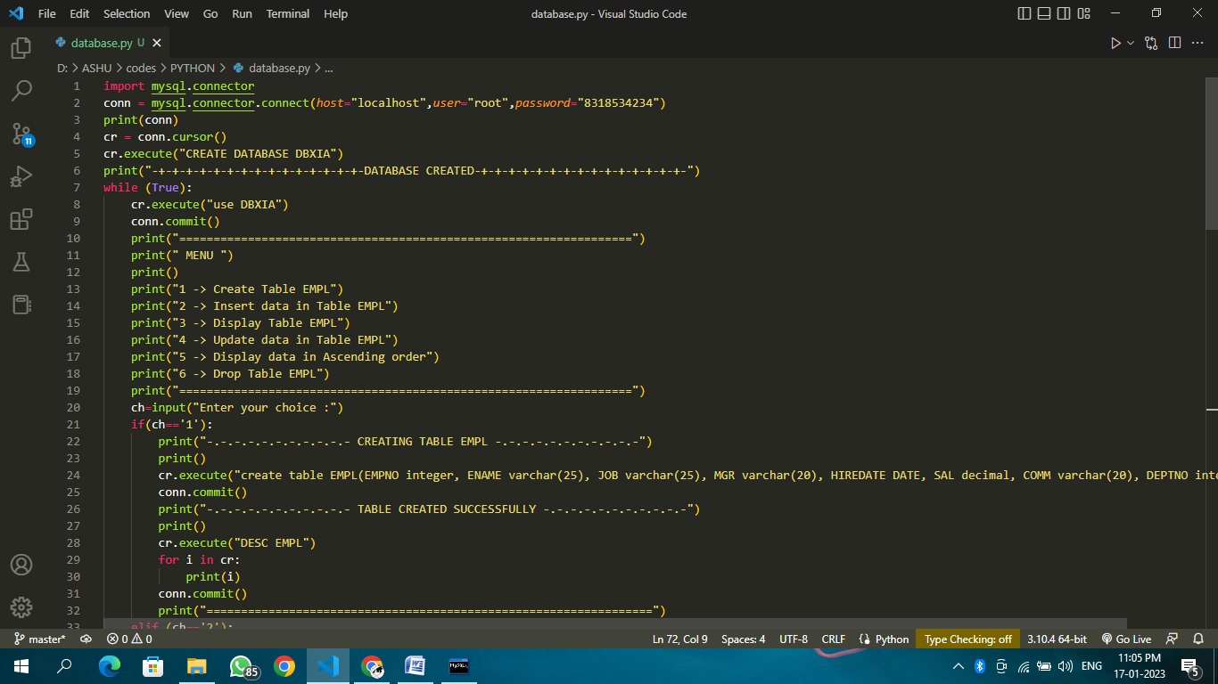

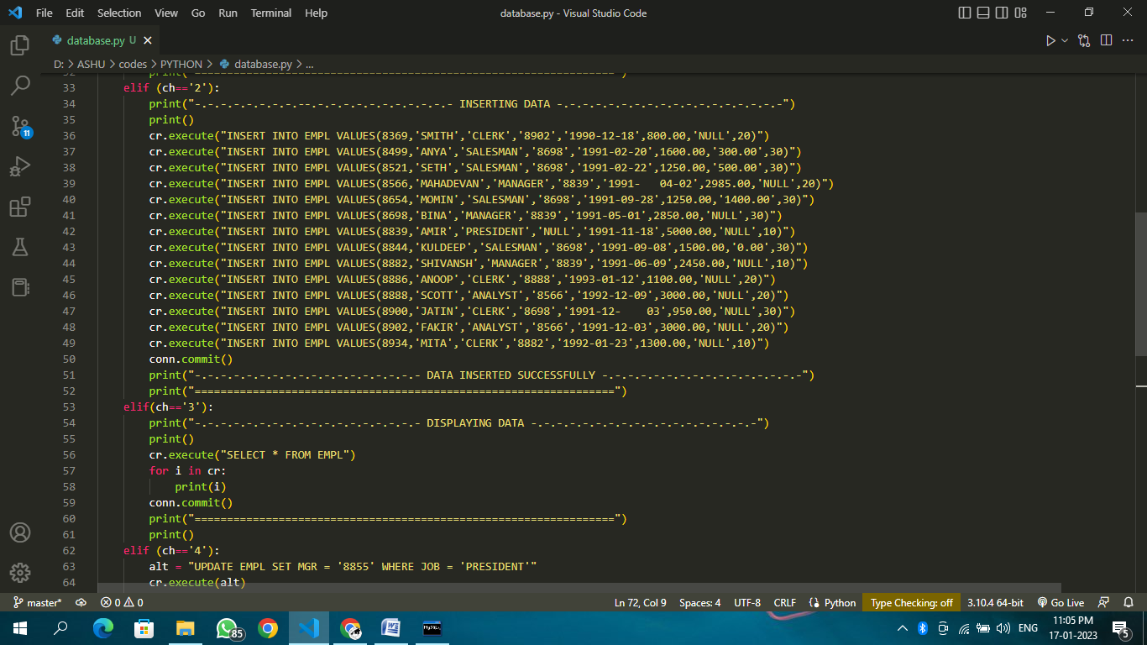

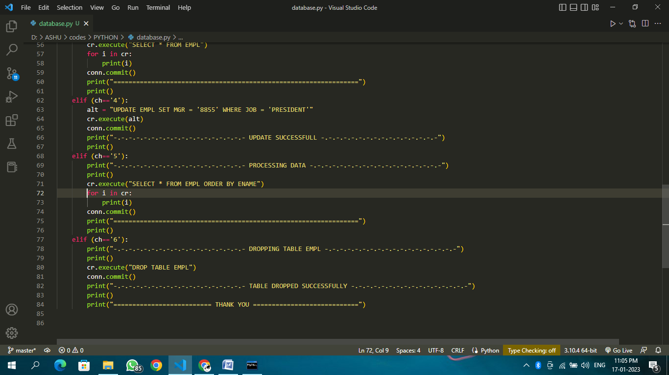

**OUTPUT**

